Add Insurers

Functionality: This dialogue allows the user to add an Insurer to the Main Org. It allows the user to capture all information necessary for billing, contacting and tracking. The Add-an Insurer dialogue, in Physia, handles the majority of this. First a review of fields will be discussed and then the action codes will be discussed.

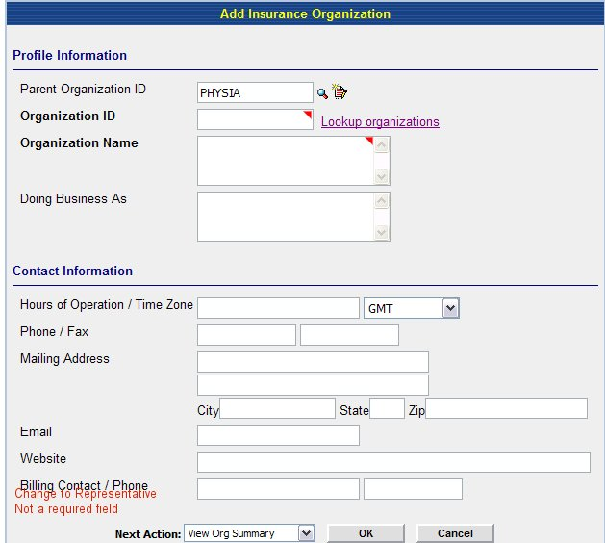
Fig 1a

Remove:
Remove from the Parent Organization ID.

Edit:
- Look up for Parent Organization II and Organization ID should both either be icons or hyperlink on words.
- Change Name of Billing Contact to Representative.

Action Codes
Look up a Parent Org Id: This lookup, whether an icon (magnifying glass or the words are a hyperlink) should take user to a search dialogue which allows the user to search for an existing organization. This should only list Associated orgs and the Main org.—see below. ***Note the method chosen for lookup should stay consistent throughout the application. **
When the user clicks the symbol or the hyperlink, it should take them to a search engine.

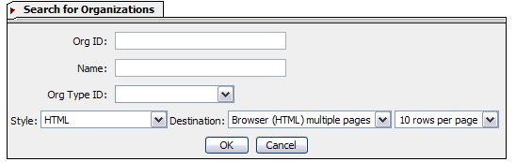

The results should consist of the following:

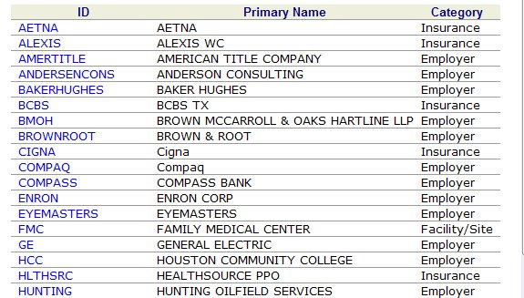

Edit:
- Ensure that results are in alphabetical order by Primary Name.
- Change name of Category column to Type.
- The only items listed in Column 3 (Category) are Associate Providers and Main Org.
- When user clicks hyperlink, the application should pull that Org Id into the Parent Org Id Field.

Look up an existing Associated Org Id: This lookup, whether an icon (magnifying glass or the words are a hyperlink) should take user to a search dialogue which allows the user to search for an existing Associated Organization. This should only list other Associated orgs and the Main org.—see below. ***Note the method chosen for lookup should stay consistent throughout the application. **
When the user clicks the symbol or the hyperlink, it should take them to a search engine.

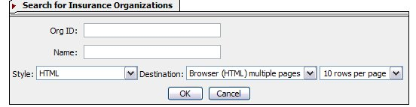

The results should consist of the following:

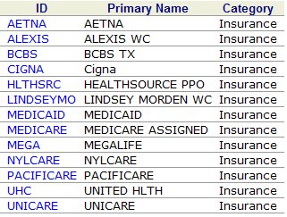

Edit:
- Ensure that results are in alphabetical order by Primary Name.
- Change name of Category column to Type.
- The only items listed in Column 3 (Category) are Insurance.
- When user clicks hyperlink, the application should pull Pop up a message stating, “ [Org ID] already exists.”→The user clicks [OK] and the application take the user to a blank Add-an Insurance Dialogue.
If the user does not see the org they requested→user closes results window→application takes user back to blank Add-an-Insurance Dialogue.

Next Action:

Once the user completes all necessary fields in Add-an-Associate Provider Dialogue, they should choose a Next Action (see below)


Add:
- “Add another Insurance” (if name is changed to Location, then make necessary changes here).
- “Go to Work List”

Edit:
Change “Go to Directory” to “Go to Search”

View Org Summary: Takes user to Organization Summary
Add another Insurance: Takes user to blank Add Insurance Screen
Go to Search: Takes user to Search engine for orgs
Return to Home: Takes user to their Home Page
Go to Work List: Takes user to Work List
Add Insurance Product: Takes user to Dialogue for Add-Insurance Product
Add Insurance Plan: Takes user to Dialogue for Add-Insurance Plan

Function:

User Clicks [OK] →Application suggests 3 Org Ids→Application should add an [OK] [Cancel] Button next to suggestions→User chooses Org Id→Clicks [OK]→ Application adds Organization and performs Next Action.

